**Supporting File for Lab No. 10**

**LAB 10.1 Working with the for Loop**

This program has the user input a number n and then finds the mean of the first n positive integers. The code is shown below:

#include <iostream> using namespace std;

int main()

{

int value; // value is some positive number n

int total = 0; // total holds the sum of the first n positive numbers

int number; // the amount of numbers

float mean; // the average of the first n positive numbers

cout << "Please enter a positive integer" << endl; cin >> value;

if (value > 0)

{

for (number = 1; number <= value; number++)

{

total = total + number;

} // curly braces are optional since there is only one statement

mean = static_cast<float>(total) / value; // note the use of the typecast // operator here

cout << "The mean average of the first " << value << " positive integers is " << mean << endl;

}

else

cout << "Invalid input - integer must be positive" << endl;

return 0;

}

Exercise 1: Why is the typecast operator needed to compute the mean in the statement mean = static_cast(float)(total)/value;? What do you think will happen if it is removed? Modify the code and try it. Record what happens. Make sure that you try both even and odd cases. Now put static_cast<float> total back in the program.

Exercise 2: What happens if you enter a float such as 2.99 instead of an integer for value? Try it and record the results.

Exercise 3: Modify the code so that it computes the mean of the consecutive positive integers n, n+1, n+2, . . . , m, where the user chooses n and m. For example, if the user picks 3 and 9, then the program should find the mean of 3, 4, 5, 6, 7, 8, and 9, which is 6.

**LAB 10.2 Nested Loops**

The code is shown below:

#include <iostream> using namespace std;

int main()

{

int numStudents;

float numHours, total, average;

int student,day = 0; // these are the counters for the loops

cout << "This program will find the average number of hours a day" << " that a student spent programming over a long weekend\n\n";

cout << "How many students are there ?" << endl << endl; cin >> numStudents;

for(student = 1; student <= numStudents; student++)

{

total = 0;

for(day = 1; day <= 3; day++)

{

cout << "Please enter the number of hours worked by student " << student <<" on day " << day << "." << endl;

cin >> numHours

total = total + numHours;

}

average = total / 3;

cout << endl;

cout << "The average number of hours per day spent programming by "

<< "student " << student << " is " << average

<< endl << endl << endl;

}

return 0;

}

Exercise 1: Note that the inner loop of this program is always executed exactly three times—once for each day of the long weekend. Modify the code so that the inner loop iterates n times, where n is a positive integer input by the user. In other words, let the user decide how many days to consider just as they choose how many students to consider.

**Sample Run:**

**This program will find the average number of hours a day that a student spent programming over a long weekend**

**How many students are there?**

**2**

**Enter the number of days in the long weekend**

**2**

**Please enter the number of hours worked by student 1 on day 1**

**4**

**Please enter the number of hours worked by student 1 on day 2**

**6**

**The average number of hours per day spent programming by student 1 is 5**

**Please enter the number of hours worked by student 2 on day 1**

**9**

**Please enter the number of hours worked by student 2 on day 2**

**13**

**The average number of hours per day spent programming by student 2 is 11**

Exercise 2: Modify the program from Exercise 1 so that it also finds the average number of hours per day that a given student studies biology as well as programming. For each given student include two prompts, one for each subject. Have the program print out which subject the student, on average, spent the most time on.

**LAB 10.3 Student Generated Code Assignments**

Option 1: Write a program that performs a survey tally on beverages. The program should prompt for the next person until a sentinel value of –1 is entered to terminate the program. Each person participating in the survey should choose their favorite beverage from the following list:

1. Coffee 2. Tea 3. Coke 4. Orange Juice

**Sample Run:**

**Please input the favorite beverage of person #1: Choose 1, 2, 3, or 4 from the above menu or -1 to exit the program**

**4**

**Please input the favorite beverage of person #2: Choose 1, 2, 3, or 4 from the above menu or -1 to exit the program**

**1**

**Please input the favorite beverage of person #3: Choose 1, 2, 3, or 4 from the above menu or -1 to exit the program**

**3**

**Please input the favorite beverage of person #4: Choose 1, 2, 3, or 4 from the above menu or -1 to exit the program**

**1**

**Please input the favorite beverage of person #5: Choose 1, 2, 3, or 4 from the above menu or -1 to exit the program**

**1**

**Please input the favorite beverage of person #6: Choose 1, 2, 3, or 4 from the above menu or -1 to exit the program**

**-1**

**The total number of people surveyed is 5. The results are as follows:**

**Beverage Number of Votes**

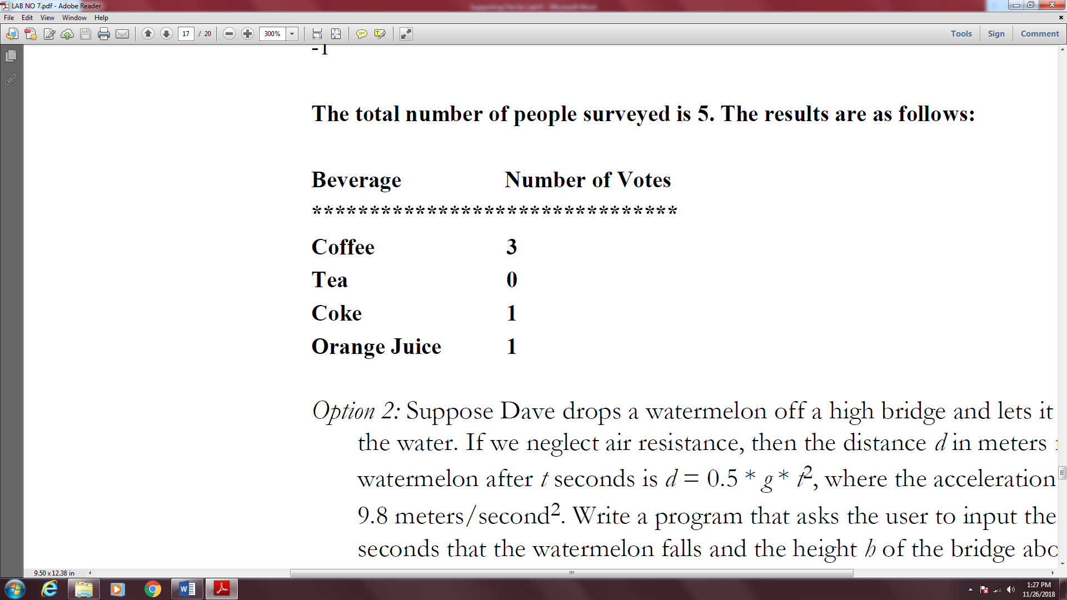

**Task 10.4**

Suppose Dave drops a watermelon off a high bridge and lets it fall until it hits the water. If we neglect air resistance, then the distance d in meters fallen by the watermelon after t seconds is d = 0.5 * g * t2, where the acceleration of gravity g = 9.8 meters/second2. Write a program that asks the user to input the number of seconds that the watermelon falls and the height h of the bridge above the water. The program should then calculate the distance fallen for each second from t = 0 until the value of t input by the user. If the total distance fallen is greater than the height of the bridge, then the program should tell the user that the distance fallen is not valid.

**Sample Run 1:**

**Please input the time of fall in seconds:**

**2**

**Please input the height of the bridge in meters:**

**100**

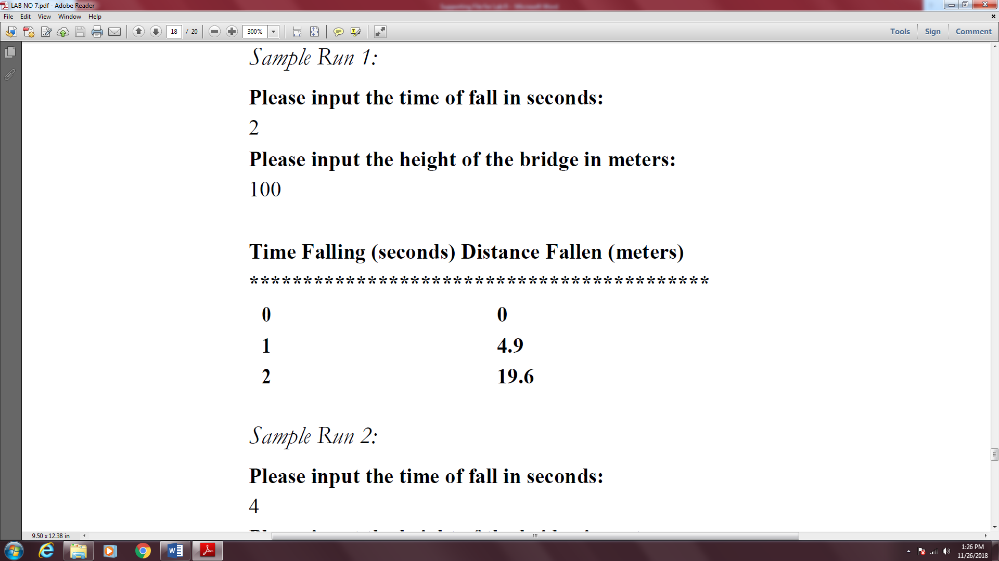

**Sample Run 2:**

**Please input the time of fall in seconds:**

**4**

**Please input the height of the bridge in meters:**

**50**

